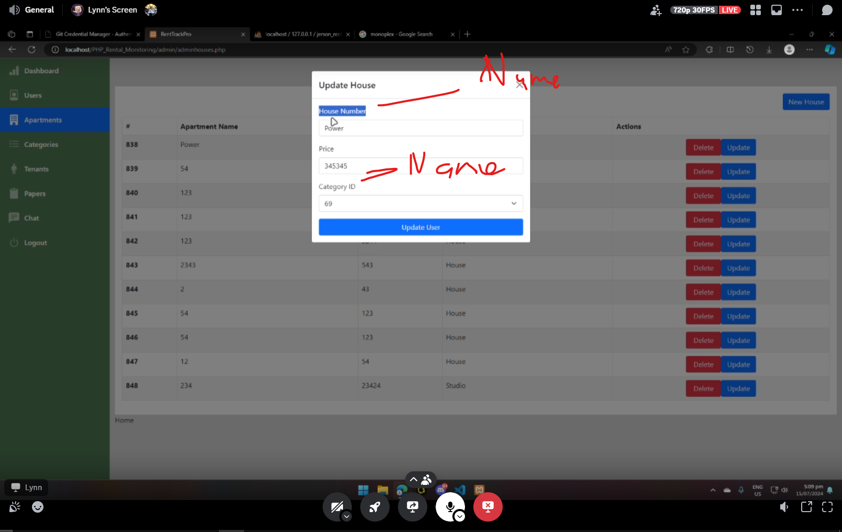

Convert to House Name and Category Name - DONE

Kulang ng Maynilad Account at Meralco Account edit for each house

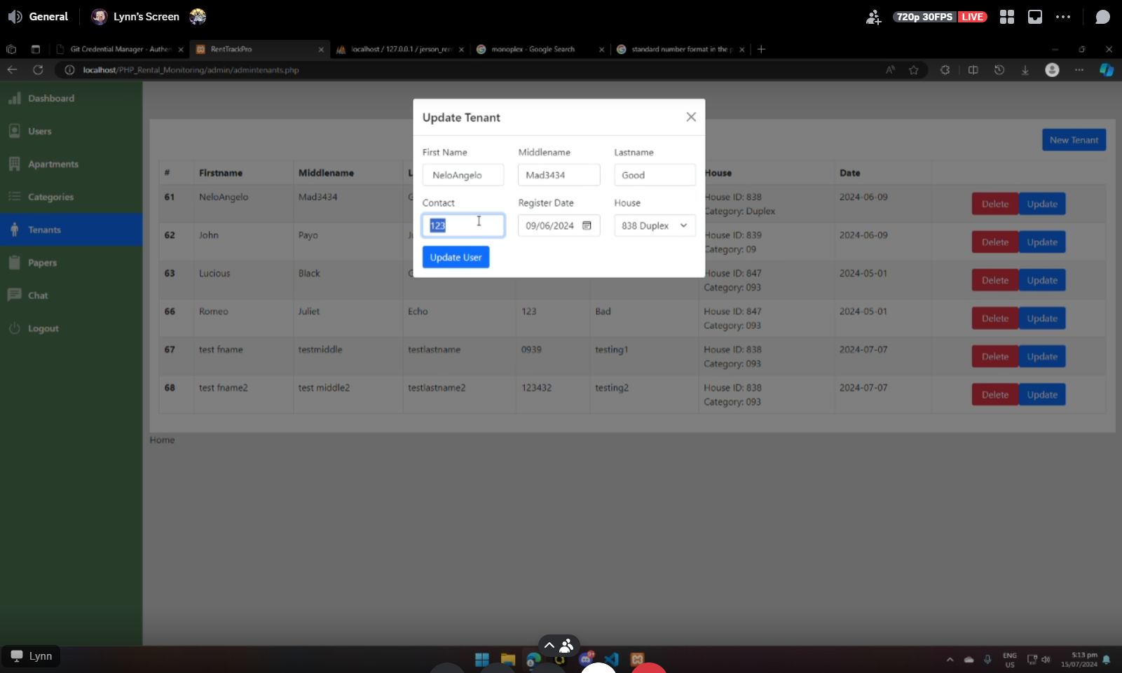

Must have format checker to have 10/11 digits

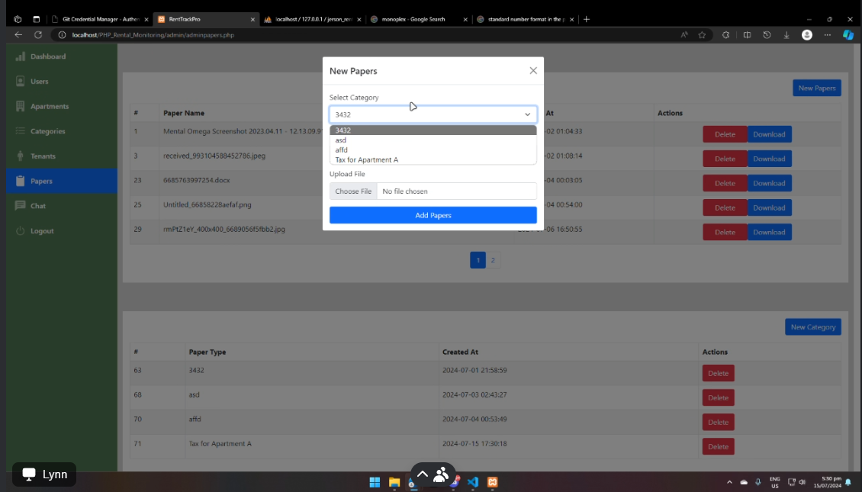

Hindi nag uupdate kagad after gawan category

Missing category column in upper table

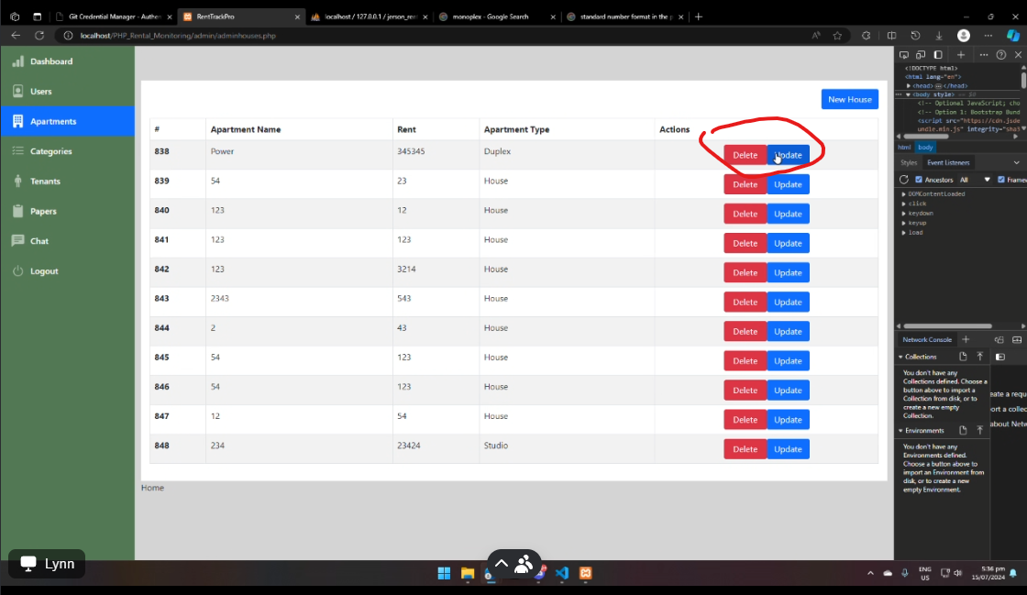

Spacing between the buttons

**USERS SIDE**

Makikita yung Meralco at Maynilad accounts

Pwede nila iupdate contact number

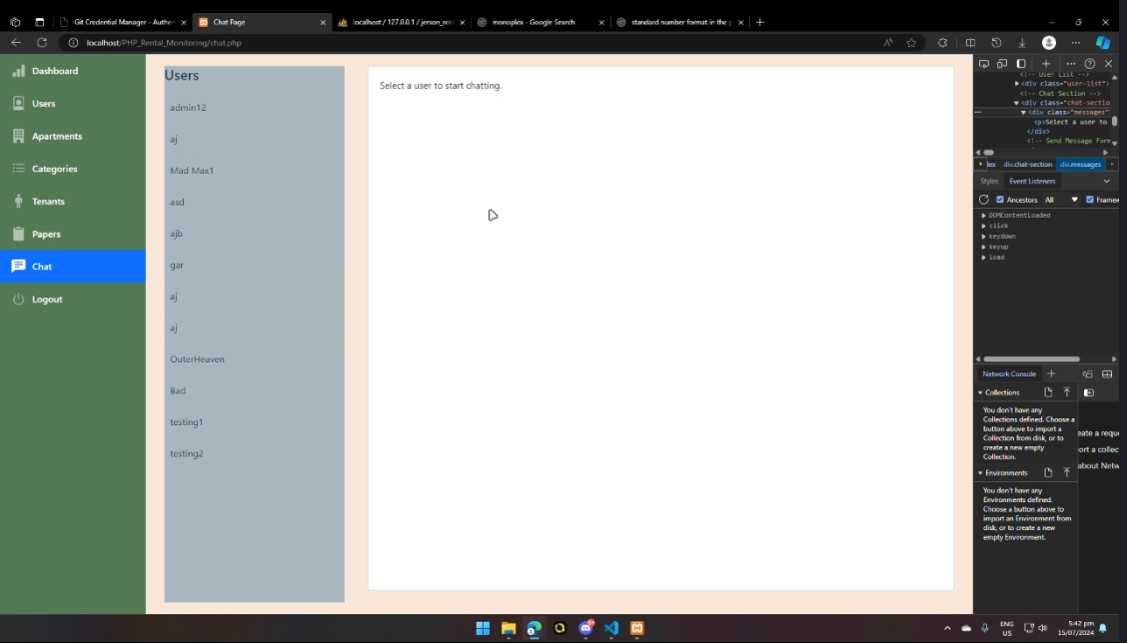

User side should not show admin looking UI